Practical - 3
Practical Title: Responsive UI Design using CSS Grid, Flexbox, and Bootstrap/Tailwind

Problem Definition: Design responsive layouts for Home, About, Registration, Dashboard, and Events pages using CSS Grid and Flexbox. Optional to use CSS framework such as Bootstrap or Tailwind. Ensure mobile-first

responsiveness.

Theory
- How does the layout adapt for mobile, tablet, and desktop screens?
Answer:
Responsive web layouts adapt across devices using fluid grids and CSS media queries to automatically rearrange content based on available screen space. On large desktop screens, content typically spans multiple columns with fully expanded navigation menus. As the screen shrinks to a tablet size, the layout usually condenses into fewer columns with larger, touch-friendly buttons. Finally, on small mobile screens, the design collapses into a single vertical column for easy scrolling, and wide navigation bars are tucked away behind a compact "hamburger" menu icon to maximize horizontal real estate.
Website used :- https://www.w3schools.com/css/css_rwd_intro.asp

- Which layout technique is used and why?
Answer:
In responsive UI design, these techniques are typically used together as a combined strategy. CSS Grid handles the overall two-dimensional page structure (like dashboard layouts and galleries) because it manages both rows and columns simultaneously. Flexbox controls the one-dimensional alignment inside individual components (like navigation bars or button rows) because it excels at distributing space and centering content along a single axis. Frameworks like Bootstrap or Tailwind are used to apply these Grid and Flexbox layouts rapidly via pre-built utility classes, ensuring quick development and consistent responsive breakpoints without writing custom CSS media queries manually.
Website used :- https://developer.mozilla.org/en-US/docs/Web/CSS/Guides/Grid_layout/Relationship_with_other_layout_methods

3. Are typography, spacing, colors, and contrast readable?
Answer:
Yes, the typography, spacing, colors, and contrast are fully readable and optimized for accessibility. Clear font choices and well-balanced line spacing ensure the text is easy to scan, while color combinations meet standard contrast requirements to accommodate users with visual impairments. Together, these design choices enhance overall legibility and create a comfortable user experience across all StudentHub pages.

4. How will GitHub commits be maintained after each practical?
Answer:
GitHub commits will be maintained through regular, incremental updates following the completion of each practical task or milestone. Each commit will feature a clear, descriptive message outlining the specific changes made—such as implementing semantic layout tags, updating navigation, or adding accessible form elements—ensuring a well-documented and organized version-controlled history of the StudentHub project in the repository.

Implementation/ Output/Result
The StudentHub pages feature fully responsive layouts built using CSS Grid for multi-dimensional content organization and Flexbox for streamlined, one-dimensional alignment and navigation. As a result, the interface seamlessly adjusts across mobile, tablet, and desktop screens while preserving a uniform look and feel through consistent typography, spacing, colors, and design styling.

Evidence of Work (Screenshots)

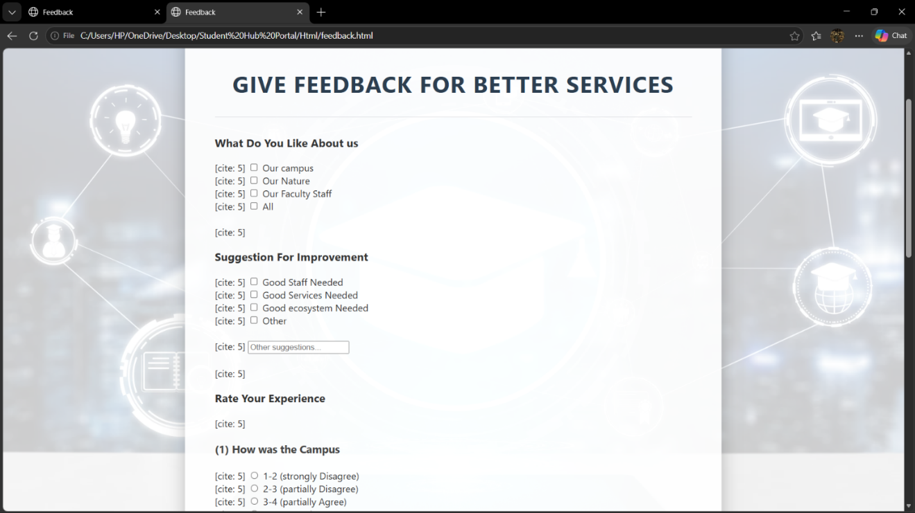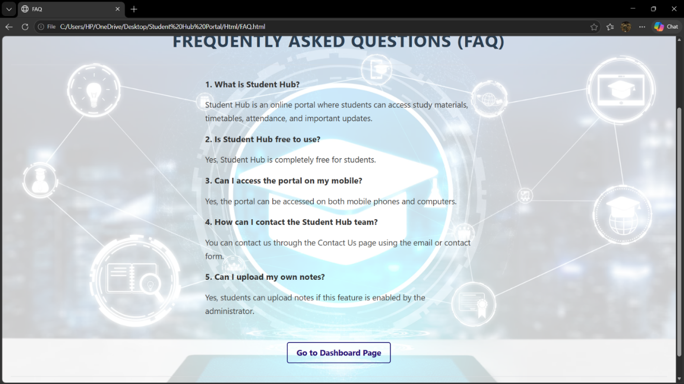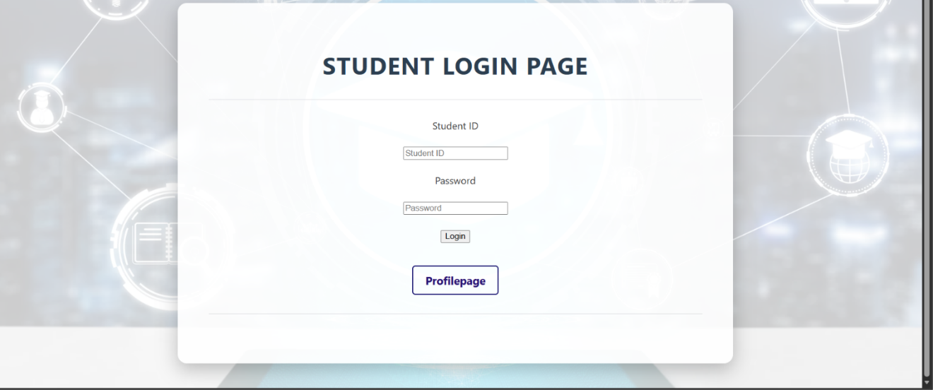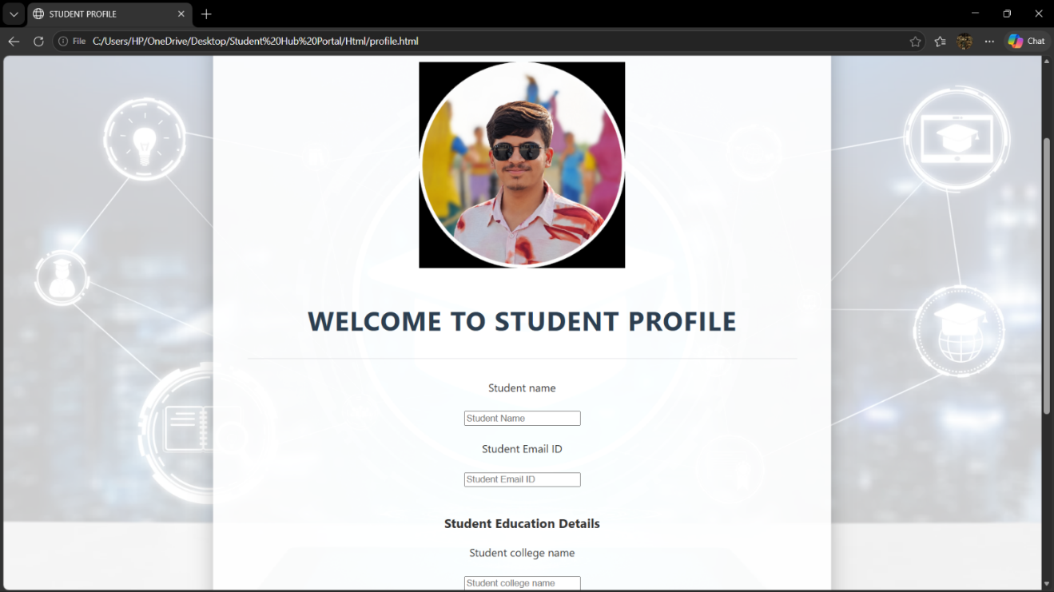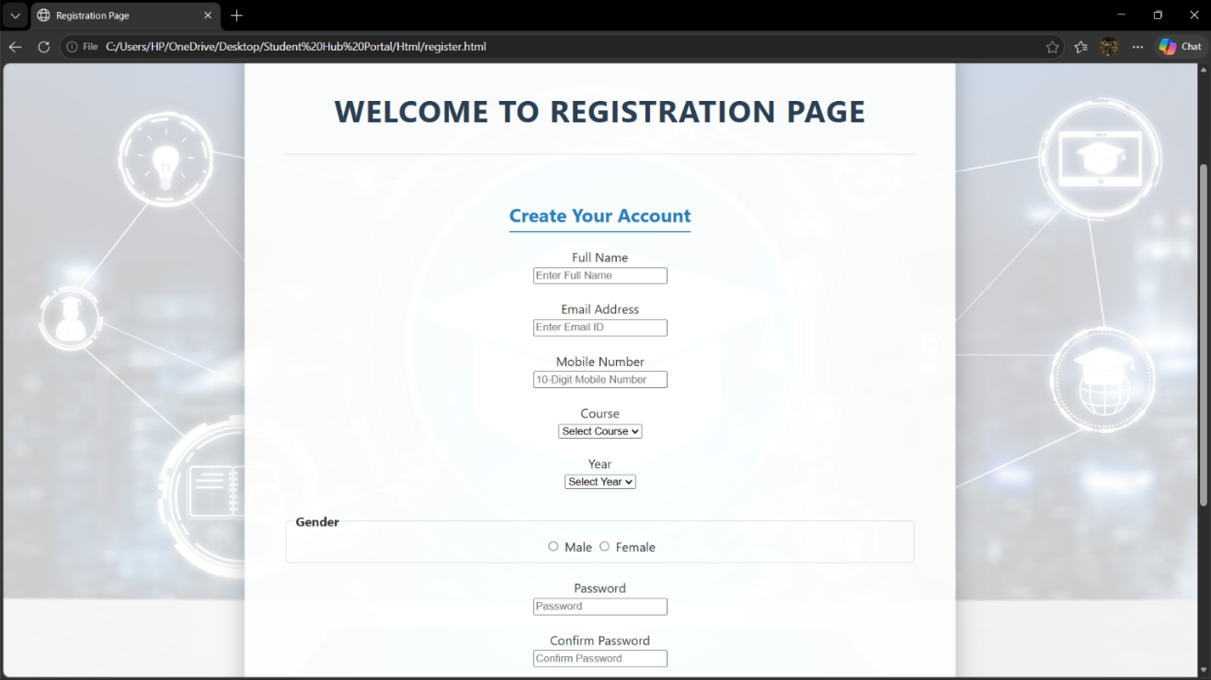

GitHub Repository Link:
https://github.com/RajMonani/Student-Portal-Hub

Challenges Faced:
Developing the responsive StudentHub interface presented several key layout and styling challenges. Key difficulties included determining when to apply CSS Grid versus Flexbox, dynamically adjusting grid column counts for dashboard cards, and using media queries effectively across tablet and mobile breakpoints. Additionally, preventing navigation elements and text from overflowing on smaller screens while maintaining uniform typography and spacing required careful styling, alongside keeping the CSS modular without resorting to inline styles. These obstacles were overcome by iteratively inspecting layouts with browser developer tools and refining Grid properties, Flexbox rules, and media query breakpoints accordingly.

Learning Outcomes:
Through this practical, I gained hands-on experience in building fluid, responsive layouts using modern CSS3 techniques. I mastered using Flexbox for one-dimensional element alignment and CSS Grid for structured multi-column content, alongside adopting a mobile-first design strategy with media queries. Furthermore, I learned how to structure reusable external CSS rules, maintain harmonious visual design principles—including typography, color contrast, and spacing—and leverage browser developer tools to verify responsiveness, ensuring an optimal user experience across all screen sizes.

Faculty Remarks:

